Standard Operating Procedure (SOP) for use of the Online Non-Prescription Ordering Service (ONPOS)

Version and date:  V1.0 June 2019 | Authors  [Lisa York, Sheila Brown]
Review date: April 2021 | Or earlier in view of clinical, formulary or process change

AIM
To implement Online Non Prescription Ordering Service (ONPOS) in East Kent, to support cost effective use of wound care products and compliance with the First Choice Dressings List (FCDL) within Kent Community Health NHS Foundation Trust (KCHFT) teams, nursing homes and GP practices.

SCOPE
This Standard Operating Protocol (SOP) covers use of ONPOS within the KCHFT teams, care home (Nursing) and GP practices for patients with wound care needs.
ONPOS
- Is an alternative procurement solution for wound care products.
- is provided by Coloplast Ltd (www.onpos.co.uk) under a working with industry protocol agreed with the east Kent CCG’s.
- allows for orders to be placed on an online portal for dressings in bulk which are held as stock at nominated bases.
- negates the need for prescriptions to be generated and as the stock dressings do not belong to a named patient they can be used for any appropriate patient. This means appropriate dressings are immediately available and patients are only supplied with the number of dressings needed rather than whole boxes.

RESPONSIBILITIES
- The Medicines Management Team (MMT), working across all four East Kent Clinical Commissioning Groups (CCGs), including Ashford, Canterbury & Coastal, South Kent Coast and Thanet, will be responsible for implementing and monitoring ONPOS collaboratively with Coloplast. Any issues should be reported to the MMT Project lead.
The MMT will work with providers’ Tissue Viability (TV) teams to provide a First Choice Dressing List (FCDL) which should cover the majority of requirements. Products available to order on ONPOS are those that feature on the FCDL. There are currently four different lists used on the ONPOS system set out at the end of this section of the SOP.

- The organization’s nominated clinical lead has responsibility for ONPOS for a specific location. The lead should ensure staff accessing the system are competent to do so and are compliant with the SOP. An ONPOS base lead and an ONPOS base deputy within each base are responsible for ordering, receipt, storage and stock control of products. Subsequent users can be given access to the system if determined by local need (known as a designated person).
The nominated clinical lead must arrange for suitable storage areas for products which must comply with the following:
- Ensure suitable storage is provided e.g. clean, dry and shelving is available to keep products off the floor
- Storage is lockable with access restricted to staff within the organisation responsible for ONPOS supply
Room temperature is monitored at all locations in accordance with the organisations guidelines:
  - Ensure a thermometer is available in all locations where medicines are stored to monitor the ambient temperature.
  - Ensure current, maximum and minimum ambient temperatures are recorded daily by a designated person.
  - In the event of a temperature not being in the required range, please refer to your organizational guidelines for guidance.

Staff selecting products from the base ONPOS store must
  - Complete the required requisition forms for all products taken or returned to the base.
  - provide details of the named patient for items on the named patient list
  - only request items outside of ONPOS on the Additional Product order form.
Products taken to the patient’s house or room must be only those required for that dressing
Additional products should not be left in a patient’s home or room as they then are unable to be used as
Stock. Supplies should only be left if the clinician is satisfied that products will be stored appropriately and free from contamination.
All supplies should be transported into a patient’s home in an opaque carrier bag to maintain patient confidentiality.
The only exception to this is for products from the named patient list formulary.

In exceptional circumstances, dressings may be transferred between bases to minimize wastage and unnecessary costs This can only be actioned when the required paperwork has been signed off by the MMT project lead. Please contact the MMT Project lead if there is an over stock position and the MMT Project lead will action this if appropriate. Base staff must NOT move items between bases without MMT project lead input.

- Supplies are ordered by the base from a designated community pharmacy.
The pharmacy must ensure:
- They update the base staff and MMT project lead if contact names or details change
- They can supply all products
- Have access to the necessary IT systems
- Have undertaken the appropriate training
- Deliver bulk orders to ordering bases within the required timescale
- Ensure that they obtain signed receipts for delivery of products to ordering locations
- Maintain proactive communication with ordering locations
- Work within the stipulations as detailed on the Service Level Agreement

- Coloplast is responsible for providing a designated Accounts Manager who facilitates access to the system as well as training before the system becomes operational. The Accounts Manager produces monthly reports and dashboards as determined by the MMT. Coloplast will facilitate the inclusion of local pathways or guidelines onto the system as requested by the MMT, as well as communications about product changes or quantity restrictions as applicable. Coloplast will also arrange for additional products to be added to the system for ordering providing that the approved method has been followed. A helpline is also provided to assist with queries, the number is; 01733 392389

METHOD
- Details of responsibilities are set out in the ONPOS Provider contract (Appendix 1 )
- A contact sheet needs to be completed for each base (Appendix 2) and kept in a clearly labeled folder with all other ONPOS administration documents. A copy must be sent electronically to the MMT project lead when the base goes live and in the event of any changes in names or contact details
- Ordering stock from ONPOS- a guide is provided in Appendix 3
Stock levels will be determined locally but should be based on a maximum/minimum approach with the flexibility to increase levels dependent upon current caseload.
Data will be provided by the MMT to guide such levels once a base has been fully operational on ONPOS for a minimum of 3 months.
Such data will be reviewed on a regular basis.
Minimum order amounts act as the trigger points for an order to be generated.
Orders should not usually be requested until the minimum order quantity has been reached

If an error is made when ordering i.e. Incorrect quantity, the following action must be taken;

- Ask the pharmacy not to process the order using the 6 digit order number to confirm which order needs to be cancelled
- Record the contact name from the Pharmacy the cancellation was agreed with, who from the base called and the date of the call in case of the order still sent.
- Contact the ONPOS helpline and ask for the whole order to be deleted from the system.
- Re-create a new order.
If an item is ordered in error, if the above steps have not been taken, the pharmacy is currently NOT able to accept a return or provide a credit. This section will be amended if a process is put in place
The ONPOS base lead/deputy is responsible for ensuring that the stock cupboard is kept orderly so that available stock can be viewed easily to prevent unnecessary orders. They are also responsible for ensuring that stock held within bases has not passed the expiry date and that stock is rotated when further orders are supplied to minimize this risk. These duties may be delegated to a designated person providing they are deemed competent to complete these requirements. Please ensure that all contacts at the base are recorded on the contact sheet and notified to the CCG’s MMT Project lead.
- Receiving order from ONPOS. A guide is provided in Appendix 4
If an item is received which is incorrect or there is a shortfall the pharmacy must be contacted and will rectify the error.
Record the contact name from the Pharmacy who you discussed the error with, who from the base called, the date of the call and the agreed action in case of further queries.

- Requisition Sheet (Appendix 5)

Staff using products from ONPOS must ensure that when stock has been removed from or returned to the base that the Requisition Sheet is used to record:
  - patient initials,
  - stock item details including dressing name, size and quantity
  - The named member of staff responsible for the removal/return of stock.
A separate sheet will be used each day
The aim of recording such data provides an audit trail and will support decision making around stock ordering

It will be expected that stock takes will take place on a quarterly basis to seek assurance that appropriate stock levels are held as previously agreed and are within expiry dates. The responsibility will lie with base staff to carry out this task and record this on the ONPOS System when it has taken place. It will be expected that CCG MMT could carry out random spot checks as deemed necessary to audit stock levels. (See Appendix 6) on how to carry this out.

- Named patient list-order form (Appendix 7) are multiple products with similar names on this list including options for sizes and colours of products.
PIP codes (process to be updated once FCDL update complete – expected Sept 19) are designed to minimise the risk of selecting the wrong product and should be used for products on this list. Healthcare professionals must provide the PIP code to enable administrators to select the correct product. Supplying the wrong product could put the patient at risk due to incorrect compression, delay in treatment and adds to waste.
Administration must order by entering the PIP code first NOT the product name. PIP codes are deliberately not sequential for a product group unlike manufactures’ codes
Where items are required from the named patient list, patient details must be provided by the requesting member of staff to the ONPOS base lead when ordered to enable items to be promptly provided to the correct patient. Patient initials should be included on the special instructions section of ONPOS Patient identifiable details cannot be added to the ONPOS system so must be sent via secure nhs.net. Please note community pharmacies will not be able to deliver these items to a patient.

- Barrier products request form (Appendix 8)
Where barrier products are required although barrier products are held as stock, a barrier products request form must be completed and provided to the base administrator. Barrier products can be ordered in bulk but order quantities will be based on confirmation that fully completed request forms have been submitted to the ONPOS Base lead/deputy.
Proshield products- A new form is to be completed each time a request for Proshield products are required.
Cavilon - barrier form needs to be completed at initiation with an expected end date or rationale for continuation.
Please ensure that these forms are retained at the base for audit purposes.
- Additional Product Request (Appendix 9)
If there is a clear rationale for an alternative product to be used which has been approved by the Tissue Viability Service and does not appear on the FCDL, it can be arranged for products to be added to the named patient list of the formulary for a maximum period of 4 weeks. This can be achieved by raising a request using the Additional Product Request form. Once the form has been completed, please email
accg.eastkentprescribing@nhs.net to seek approval, a decision will be made within 2 working days.
- TVN/Wound Clinic request ordering for a clinical location
TVN staff can order from an extended list of products and delivered to a specific base using their relevant base login. Patient initials must be added to the special instructions on the order so that the base knows the request is for a specific patient and the requested patient items are available in a timely manner.ie. for patient Anne Smith, information in the special instruction section must read ‘Patient AS-on TVN advice ‘, This is to ensure that there is no identifiable patient data but a process to notify the base when an order has been placed for a specific patient.
Please note, community pharmacies will be not be able to deliver these items to a patient
- Stock re-distribution pathway (Appendix 10)
Stock can be transferred between sites within the same CCG if required, but this should not be on a regular basis, please advise the MMT Project lead if this is necessary please follow the agreed pathway and complete the required form (Appendix 11)

Current lists available on ONPOS

Lists available on ONPOS | Description
Standard list | Contains all items on the First Choice Dressing List apart from those on the Named patient list  Items can be ordered and held as stock items
Named patient list | Hosiery and garments  These items should not be ordered to be held as stock.  Patient details must be provided to the ONPOS base lead when ordered to enable items to be promptly provided to the correct patient  Barrier products  A small stock may be held but a ‘barrier product request form’ with patient details must be provide to the ONPOS base lead each time a Proshield product is selected and at initiation until review point for Cavilon
TVN/Wound clinic list | This list contains additional products to the standard list.  Items can be  - held as stock at wound clinic bases  or  - Ordered by specialist staff for delivery to other bases on a named patient basis.  Patient initials must be added to the special instruction section on ONPOS when ordered to enable items to be promptly provided to the correct patient by the receiving base
Care Home list | This list contains a limited number of items from the standard list.  Care home also have access to items on the ‘Named patient’ list

Appendix 1 ONPOS Provider contract
Online Non Prescription Ordering System (ONPOS)-Provider contract
Providing wound care stock at nursing/practice /care home bases has a number of benefits
It allows rapid access to a range of dressings and appliances to support prompt care for patients and reduces workload for nursing and practice staff as regards the order process
The service is funded by the CCG but it does require the provider organisation to provide a level of support

The nominated clinical lead for each provide organisation is required to agree to the following conditions

- Appoint an ONPOS base lead and deputy and if necessary further designated persons and ensure the CCG lead is aware of and updated with all contact details
- Ensure the roles of the above staff includes
  - Training on the ONPOS process
  - Time to review and organise stock prior to placing an order
  - Be on site to check receipt of order within 24 hours of delivery and notify the pharmacy of any discrepancy
  - Liaise with staff from the pharmacy/ONPOS/CCG in the event of any queries
  - Complete monitoring requirements such as temperature records
  - Provide an anonymised summary of items requested from the 'named patient' list and confirm orders have been only been placed in line with these requests

Nursing staff
- Must only take reasonable amounts of stock for immediate nursing needs – stock from the standard list should not be taken to be left in patients own homes
- Provide all required information on the forms provided for items on the ‘named patient’ list
- Only take stock for patients on the case load for that base
- Do not transfer stock between bases

I agree to provide the above support for the ONPOS system.

I agree to provide the above support for the ONPOS system.
Organisation
Nominated clinical lead (please print)
Role
Signature
Date
To be countersigned by the CCG project lead and a copy returned to the ONPOS nominated lead
CCG project lead (Please print)
Signature
Date

Appendix 2 – ONPOS Contact sheet

Online Non Prescription Ordering System – ONPOS contact sheet
Name | Organisation | Role | Mobile number | Telephone | Email | Comment e.g. Scheduled working days
Lisa York | East Kent Medicine Management team (MMT) | Project lead | 07904665361 |  | lisayork@nhs.net | Mon –Fri
Sally Blakey | East Kent Medicine Management team (MMT) | Project Support | 07776164897 |  | sally.blakey@nhs.net | Tues -Fri
Mark Beccarelli | ONPOS/Coloplast | Accounts Manager: | 07766245980 |  | gbmbe@coloplast.com | Mon - Fri
 | ONPOS/Coloplast | Administration |  | 01733 392 389 | admin@onpos.co.uk
 | KCHFT/care Home/practice | Nominated Clinical Lead
 | Base KCHFT/care Home/practice | Base lead
 | Base KCHFT/care Home/practice | Base deputy
 | Base KCHFT/care Home/practice | Base designated person
 | Designated community pharmacy (1) | contact 1
 | Designated community pharmacy (1) | contact 2
 | Designated community pharmacy (1) | contact 3

Appendix 3 – Ordering stock from ONPOS

Appendix 4 – Receiving order from ONPOS

Appendix 5- Requisition Sheet
Staff ONPOS Requisition Sheet’

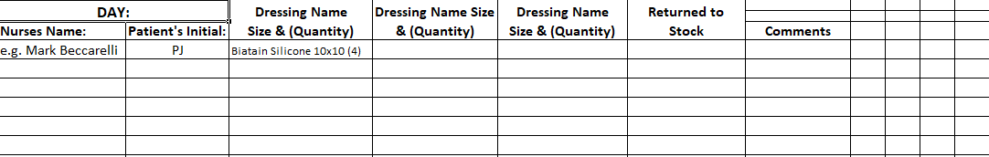

Stocktakes - Appendix 6 - To carry out your quarterly stocktake, please logon to the ONPOS system and action as per the following screen shots.
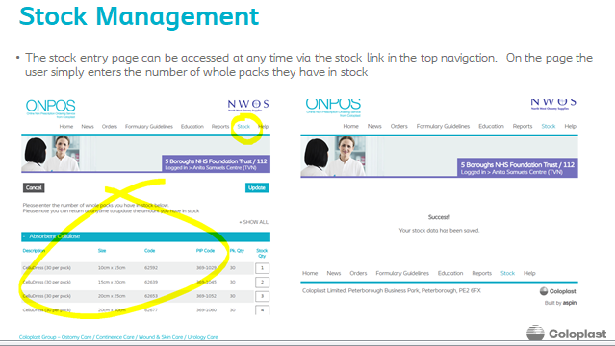

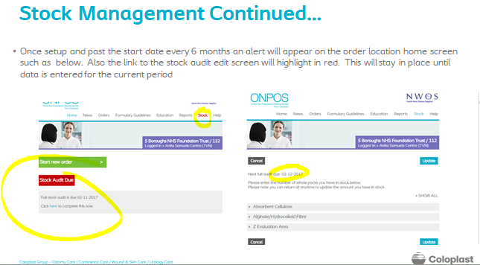
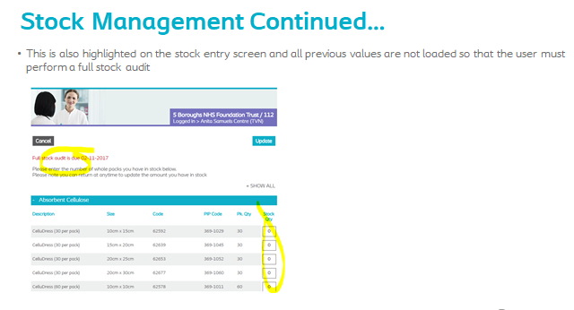
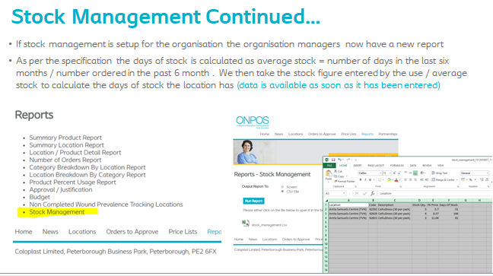

Appendix 7 - Named patient list-order form
Date

Requesters details:
Name
email address
contact telephone number
Location.
Patient Name

Limbs being treatment | Left only ☐ | Right only ☐ | Both ☐
Comments e.g. Why specific item required
Requesting nurse confirms arrangements have been made to deliver the item to the patient.
NB community pharmacies will not be able to deliver
PIP Code –Please order by PIP code to reduce chance of error with multiple similar products | Number of garments to order  (Maximum 2 per limb) | Product (ePACT name ) - do NOT use to order, only as a double check once PIP is entered

No. of garments to order (Max 2 per limb) | PIP Code – to follow | Product (ePACT name )
 |  | ActiLymph Acc For MTM Dura 2 Ankle Pads
 |  | ActiLymph Acc For MTM Dura Closed Toe
 |  | ActiLymph Acc For MTM Dura Full Compress Body Part
 |  | ActiLymph Acc For MTM Dura Oblique Toe
 |  | ActiLymph Acc For MTM Dura Slc Band
 |  | ActiLymph Acc For MTM Dura Slip Form
 |  | ActiLymph Acc For MTM Dura T Heel Ankle Seam
 |  | ActiLymph Acc For MTM Ease Class 2/3 Full Compress Body Part
 |  | ActiLymph Acc For MTM Ease Closed Toe
 |  | ActiLymph Acc For MTM Ease Oblique Toe
 |  | ActiLymph Acc For MTM Ease Slc Band
 |  | ActiLymph Acc For MTM Ease Slip Form
 |  | ActiLymph Acc For MTM Ease T Heel Ankle Seam
 |  | ActiLymph Class 1 B/Knee Closed Toe Blk Lymph Gmt
 |  | ActiLymph Class 1 B/Knee Closed Toe Sand Lymph Gmt
 |  | ActiLymph Class 1 B/Knee Open Toe Lymph Gmt
 |  | ActiLymph Class 1 Thigh Closed Toe + RegularTopBand LymphGmt
 |  | ActiLymph Class 1 Thigh Closed Toe + Wide Top Band Lymph Gmt
 |  | ActiLymph Class 1 Thigh Open Toe + Regular Top Band LymphGmt
 |  | ActiLymph Class 2 B/Knee Closed Toe Blk Lymph Gmt
 |  | ActiLymph Class 2 B/Knee Closed Toe Sand Lymph Gmt
 |  | ActiLymph Class 2 B/Knee Open Toe Blk Lymph Gmt
 |  | ActiLymph Class 2 B/Knee Open Toe Sand Lymph Gmt
 |  | ActiLymph Class 2 Thigh Closed Toe + RegularTopBand LymphGmt
 |  | ActiLymph Class 2 Thigh Closed Toe + Wide Top Band Lymph Gmt
 |  | ActiLymph Class 2 Thigh Open Toe + Regular Top Band LymphGmt
 |  | ActiLymph Class 2 Thigh Open Toe + Wide Top Band Lymph Gmt
 |  | ActiLymph Class 3 B/Knee Open Toe Wt Top Band Lymph Gmt
 |  | ActiLymph Class 3 Thigh Open Toe + Wide Top Band Lymph Gmt
 |  | ActiLymph Hose Kit Ex Exlge Stkn + Compress Liner
 |  | ActiLymph Hose Kit Exlge Stkn + Compress Liner
 |  | ActiLymph Hose Kit Lge Stkn + Compress Liner
 |  | ActiLymph Hose Kit Med Stkn + Compress Liner
 |  | Activa Leg Ulcer Hose Kit Ex Exlge C/T Compress Liner Pack
 |  | Activa Leg Ulcer Hose Kit Ex Exlge O/T Compress Liner Pack
 |  | Activa Leg Ulcer Hose Kit Ex Exlge Stkn + Compress Liner
 |  | Activa Leg Ulcer Hose Kit Exlge Clsd Toe Compress Liner Pack
 |  | Activa Leg Ulcer Hose Kit Exlge O/T Compress Liner Pack
 |  | Activa Leg Ulcer Hose Kit Exlge Stkn + Compress Liner
 |  | Activa Leg Ulcer Hose Kit Lge Clsd Toe Compress Liner Pack
 |  | Activa Leg Ulcer Hose Kit Lge O/T Compress Liner Pack
 |  | Activa Leg Ulcer Hose Kit Lge Stkn + Compress Liner
 |  | Activa Leg Ulcer Hose Kit Med Clsd Toe Compress Liner Pack
 |  | Activa Leg Ulcer Hose Kit Med O/T Compress Liner Pack
 |  | Activa Leg Ulcer Hose Kit Med Stkn + Compress Liner
 |  | Activa Leg Ulcer Hose Kit Sml Clsd Toe Compress Liner Pack
 |  | Activa Leg Ulcer Hose Kit Sml O/T Compress Liner Pack
 |  | Activa Leg Ulcer Hose Kit Sml Stkn + Compress Liner
 |  | ReadyWrap Calf Lymph Gmt
 |  | ReadyWrap Foot (Left/Right) Lymph Gmt
 |  | ReadyWrap Gauntlet Lymph Gmt
 |  | ReadyWrap Knee Lymph Gmt
 |  | ReadyWrap Quick-Fit Calf Lymph Gmt
 |  | ReadyWrap Thigh Lymph Gmt
 |  | Kerraped All Purpose Boot Medium
 |  | Kerraped All Purpose Boot Large

Appendix 8 Barrier request form - Please note that this form is used by all when requesting a barrier product not just for ONPOS, so please complete accordingly
Barrier request form
Date:
Patient name:
Patient address:
DOB:
Telephone No:
NHS number:
Name of nurse (print)
Nurse’s contact number: |  | Signature
If supplied on FP10: Patient wishes the prescription to be: | Left at the surgery for collection by patient or representative.
 | Forwarded to the pharmacy for collection by patient or carer.
 | Forwarded to the pharmacy for delivery to the patient.
If supplied on FP10: Name and address of patient ‘s pharmacy
Please note- if supplied via ONPOS pharmacy will not be able to deliver
NB. Products will only be supplied when information is provided on why there is a need to protect skin from moisture.
Is treatment required for longer than one month? | ☐ Yes | ☐ No | If yes, please confirm who will review and date. This form is valid until that date (Cavilon only) |  |  | Date of review
 |  |  |  |  |  | To be reviewed by
Has this product been ordered previously? | ☐ Yes | ☐ No | If yes, when was this product last ordered (see care plan)
If use is continuous, has TVN advice been provided, if yes when and what was the outcome? |  |  |  | ☐ Yes | ☐ No | Outcome:
Please confirm (tick box) which of the MASD or IAD criteria (see below) apply to this request and have been documented in patient notes
At risk of skin damage as patient is incontinent. No redness and skin intact |  | ☐
MILD skin damage. Red* but skin intact |  | ☐
MODERATE skin damage Red* with skin breakdown |  | ☐
SEVERE skin damage Red* with skin breakdown |  | ☐
Persistent diarrhoea |  | ☐
*Or paler, darker, purple, dark red or yellow in patients with darker skin tones
Drug Tariff Specification | Quantity requested*
Cavilon Durable Barrier Cream 28g On average this product size will last one week
Cavilon Durable Barrier Cream 92g On average this product size will last 3-4 weeks
Cavilon No-Sting Barrier Film Pump Spray 28ml
Apply every 24 hours although frequency can be reduced to 48–72 hours in line with skin improvement.
Cavilon No-Sting Barrier Film Foam Applicators 5x1ml
Apply every 24 hours although frequency can be reduced to 48–72 hours in line with skin improvement.
Proshield Plus skin protective 115g Only for use where SEVERE skin damage
Proshield Foam & Spray skin cleanser 235ml Only for patients with moisture lesions and SEVERE diarrhoea.
*For each product, only 1 pack can be requested. If additional packs are needed further information must be provided
Moisture Associated Skin damage (MASD) Pathway A http://flo/Interact/Pages/Content/Document.aspx?id=6919
Incontinence Associated Dermatitis (IAD) Pathway B http://flo/Interact/Pages/Content/Document.aspx?id=6918

Appendix 9 Additional Product Request

Online Non-Prescription Ordering Service (ONPOS) - Additional Product Request form

Date

Requester’s details: name, email address, contact telephone number, location.

Product name

Size

Dressings per pack

How long will one pack of dressings last

Anticipated duration of use(maximum 28 days)

Number of packs to be ordered on each occasion

PIP code

Clinical rationale for requesting product (if this is not complete your request will not be processed)

Please specify why a product already on FCDL is not suitable

With whom from the TVN team has use of this product been discussed and approved by the Tissue Viability Service? Please confirm name of TVN and date approved
Please complete and return to ACCG.eastkentprescribing@nhs.net your request will be actioned within 2 working days.

Authorised CCG Confirmation: Name: Date:

Appendix 10 - ONPOS stock redistribution pathway

Over Stock issue of ONPOS procured wound care products. (Overstock is defined as products that will not be used at the ordering location within 6 months)
ONPOS Stock Redistribution Pathway

Inform East Kent Medicines Management details below with the following information
- Product Brand Name
- PIP code
- Number of boxes or units over ordered

Lisa York
Project Manager (Medicines Management)
East Kent CCGs, Inca House, Ashford, Kent, TN25 4AB
Tel 07904665361 or 03000424850
E-Mail to: accg.eastkentprescribing@nhs.net

East Kent medicines Management to co-ordinate redistribution of dressing stock within local health system.

Signed copy of Pick up and drop off stock relocation for sent to Lisa York for audit purposes. (Form EKCCG SRS)

Appendix 11
ONPOS STOCK REDISTRIBUTION SHEET (SRS)
Name of Originator ……………..……………………………………………………………………………….

Telephone Number (Mobile) ……………………………………………………………………………….
NB – Products must not be returned to base stock if they have been in a patient’s house. They can only be redistributed if they have been located within a KCHFT clinical storage location.

Address of Clinical Location for Stock Uplift

Product Brand Name | Size | PIP Code | Quantity

ONPOS base transferring;
Date……………………… Signature………………………………………………………………………
Print Name……………………………………………………………………
Authorised CCG Approval
Date……………………… Signature………………………………………………………………………
Print Name……………………………………………………………………
Name and Full Clinical address details for delivery

Receiving base confirmation of receipt of items
Date…………………… Signature………………………………………………………………………
Print Name…………………………………………………………………..

Once completed please email to ACCG.eastkentprescribing@nhs.net for approval
Online Non-Prescription Ordering Service (ONPOS)
Administrators’ folder

Contents
 | Standard Operating Procedure (SOP) | Page
 | Aims
 | Scope
 | Responsibilities
 | Method
Appendix
1 | ONPOS Provider contract
2 | ONPOS contact sheet
3 | Ordering stock from ONPOS
4 | Receiving order from ONPOS
5 | Stock requisition Sheet
6 | Stock take screenshots
7 | Named patient list-request form
8 | Barrier products-request form
9 | Additional Product-request form
10 | Stock redistribution pathway
11 | Stock redistribution request form
 | Supporting information
 | Standard list- table – awaiting final version
 | Standard list- pictorial guide – awaiting final version
 | TVN/Wound clinic list – awaiting final version
 | Care home list - awaiting final version
Moisture Associated Skin Damage (MASD) Pathway A, Dec 2018
https://www.canterburycoastalccg.nhs.uk/about-us/prescribing-advice/?assetdetcd02eb11-e357-4e69-8792-6f0209cbfc22=470136&categoryesctlcd02eb11-e357-4e69-8792-6f0209cbfc22=9845

Incontinence skin care pathway B, Dec 2018
https://www.canterburycoastalccg.nhs.uk/about-us/prescribing-advice/?assetdetcd02eb11-e357-4e69-8792-6f0209cbfc22=470137&categoryesctlcd02eb11-e357-4e69-8792-6f0209cbfc22=9845

FAQ relating to Barrier products EKPG March 2019
https://www.canterburycoastalccg.nhs.uk/about-us/prescribing-advice/?assetdetcd02eb11-e357-4e69-8792-6f0209cbfc22=475612&categoryesctlcd02eb11-e357-4e69-8792-6f0209cbfc22=9845
Care home agency staff administering items supplied under ONPOS-EKPG Recommendation-March 201
https://www.canterburycoastalccg.nhs.uk/about-us/prescribing-advice/?assetdetcd02eb11-e357-4e69-8792-6f0209cbfc22=472390&categoryesctlcd02eb11-e357-4e69-8792-6f0209cbfc22=9845

